AP Human Geography

Greetings Students and Parents!

I am excited that you are going to embark on the amazing journey that we call AP Human Geography. This letter contains important information about the course as well as the first reading assignment, so please review it carefully!

Throughout the upcoming year, students will be challenged to look at the world from different viewpoints and formulate opinions based upon geographic standards of inquiry. This will include systematic studies of population, culture, language, religion, politics, agriculture, industrialization, and urbanization. Students will find this course to be both rewarding and challenging. Remember, I am here to help guide students and parents through this demanding process. If at any time you have questions, problems, concerns, or are feeling overwhelmed PLEASE contact me immediately. I cannot help you if I do not know that you are struggling.

This course places a heavy emphasis on reading. Consequently, students can expect to be engaged with reading assignments EVERY night. Reading assignments will include textbooks, novels, and articles from newspapers and academic journals. Students will read four full-length novels/non-fiction titles over the course of the year. All required novels are described in detail on the next page. Digital or electronic versions are acceptable when accessible from MJHS.

I look forward to a fun and exciting year. If you have any questions or concerns about the course, please do not hesitate to contact me at camille.benson@maryville-schools.org.

Sincerely,

Camille Benson
Maryville Junior High School
AP Human Geography
World History & Geography

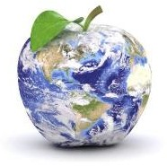
AP Human Geography

2021-2022 Reading Requirements

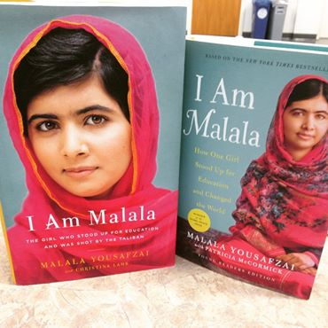
I am Malala by Malala Yousafzai - In 2009 Malala Yousafzai began writing a blog on BBC Urdu about life in the Swat Valley as the Taliban gained control, at times banning girls from attending school. When her identity was discovered, Malala began to appear in both Pakistani and international media, advocating the freedom to pursue education for all. In October 2012, gunmen boarded Malala's school bus and shot her in the face, a bullet passing through her head and into her shoulder. Remarkably, Malala survived the shooting. At a very young age, Malala Yousafzai has become a worldwide symbol of courage and hope. Her shooting has sparked a wave of solidarity across Pakistan, not to mention globally, for the right to education, freedom from terror and female emancipation. Students must have it read by the first day of class. We will be spending a majority of time during the first week discussing the book and how it relates to Human Geography. There will be an exam given over the book during the first week of class.

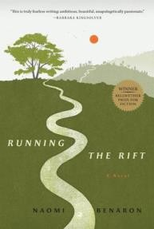
Running the Rift by Naomi Benaron – This historical fiction novel follows an aspiring Olympic runner trying to survive during the 1994 Rwandan Genocide. Students will be expected to purchase this book and have a copy available to use during class discussions. Students are not required to read it over the summer; instead reading assignments will be given over the course of the school year. Questions from this book will be incorporated into exams and essay topics.

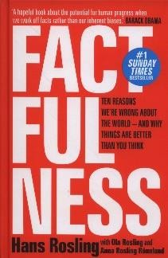
Factfulness by Hans Rosling – When asked simple questions about global trends―what percentage of the world’s population live in poverty; why the world’s population is increasing; how many girls finish school―we systematically get the answers wrong.
Factfulness offers a radical new explanation of why this happens. It reveals the ten instincts that distort our perspective―from our tendency to divide the world into two camps (usually some version of us and them) to the way we consume media (where fear rules) to how we perceive progress (believing that most things are getting worse).

It turns out that the world, for all its imperfections, is in a much better state than we might think. That doesn’t mean there aren’t real concerns. But when we worry about everything all the time instead of embracing a worldview based on facts, we can lose our ability to focus on the things that threaten us most. Students are not required to read this book over the summer; instead reading assignments will be given over the course of the school year. Questions from this book will be incorporated into exams and essay topics.

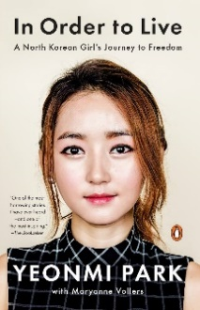
In Order to Live by Yeonmi Park - Yeonmi Park was not dreaming of freedom when she escaped from North Korea. She didn't even know what it meant to be free. All she knew was that she was running for her life, that if she and her family stayed behind they would die - from starvation, or disease, or even execution. This book is the story of Park's struggle to survive in the darkest, most repressive country on earth; her harrowing escape through China's underworld of smugglers and human traffickers; and then her escape from China across the Gobi desert to Mongolia, with only the stars to guide her way, and from there to South Korea and at last to freedom; and finally her emergence as a leading human rights activist - all before her 21st birthday. Students are not required to read this book over the summer; instead reading assignments will be given over the course of the school year. Questions from this book will be incorporated into exams and essay topics.

