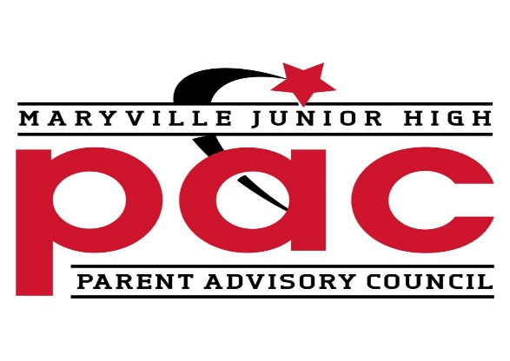
Meeting Agenda
November 15, 2022
11:30am

- Approve October Minutes
- Financial Report
- Teacher Appreciation Update
- Career Fair
- Butter Braids Update
- Administrative Update
  - Gingerbread Project
  - Course Registration 23-24
Next Meeting: January 17

2023 Meeting Dates- 11:30am
January 17 March 21
February 21 - grants April 18

